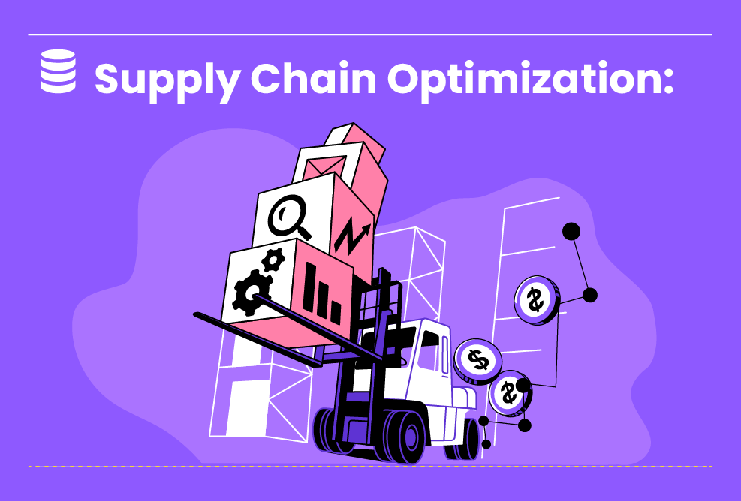

Not So Easy

**Supply Chain Efficiency and Inventory Management Analysis**

In this lab, you will explore a dataset related to supply chain operations and inventory management. You will perform data analysis and visualization tasks to identify bottlenecks, forecast demand, optimize inventory levels, and evaluate supplier performance. Through hands-on exercises, you will gain insights into improving supply chain effi...

Duration : 18 Hours

Not So Easy

3 Steps

**Project Objective**

The objective of this lab is to familiarize you with supply chain data analysis techniques and provide practical experience in optimizing inventory management and enhancing overall supply chain performance.

**Inspiring Project Examples**

https://www.ibm.com/topics/supply-chain-analytics

https://www.sap.com/insights/inventory-optimization.html

https://www.youtube.com/watch?v=lLeFVA6rFX8&list=PLJqiHnBNjacq6AAH3EHWhvGL6yak7usXz

**Step By Step**

On this project, you will pass by these steps. All steps must be done to successfully complete this project.

**KPI Identification and Analytical Questions**

In This Phase, You Will Learn How To Gather Relevant Data From Various Sources Such As Procurement Systems, Inventory Databases, Logistics Information, And Supplier Records. The Objective Is To Collect Comprehensive And Accurate Data To Support Your Analysis And Decision-Making. Additionally, You Will Identify Key Performance Indicators (KPIs) That Are Essential For Assessing Supply Chain Efficiency And Inventory Management.

**Data Warehouse Modeling**

During This Phase, Students Will Delve Into The Analysis Of Supply Chain Data. They Will Learn How To Identify Bottlenecks, Forecast Demand, Optimize Inventory Levels, And Evaluate Supplier Performance Using Analytical Techniques And Statistical Models. Students Will Gain Insights Into The Factors Influencing Supply Chain Efficiency And Develop Skills In Applying Data-Driven Strategies For Process Improvement.

**OLAP Analysis and Reporting**

In The Final Phase, You Will Focus On Creating Visualizations And Reports To Effectively Communicate Supply Chain Metrics And Insights. Using Data Visualization Tools, You Will Track Key Performance Indicators, Identify Trends, And Visualize The Flow Of Goods In The Supply Chain. Real-Time Dashboards Will Enable You To Monitor Inventory Levels And Track Supplier Performance, Empowering You To Make Informed Decisions And Proactively Manage The Supply Chain.

**Instructor Guideline**

Prepare step-by-step instructions for the data analysis and visualization tasks. Provide relevant explanations and insights to help students understand the significance of each analysis and its implications for supply chain efficiency and inventory management. Encourage students to explore additional resources and case studies to deepen their understanding of supply chain analytics.

**Guidelines Ressources**

https://pubsonline.informs.org/doi/abs/10.1287/trsc.2017.0804